Insurance Prediction Model

Objective:
To predict the insurance changes for the provided dataset to the client. Dataset has been received along with input and output variables.

Problem Identification:
- Domain Selection - As per my data sheet, my output (Interest Charges) deals with numbers and my domain will be Machine Learning.
- Learning Selection – The dataset falls under Supervised learning, since my requirement is clear and input, output variables are pre- defined.
- Supervised Learning – (Regression or Classification) – My dataset output would be decimal values and hence this falls under Regression.

Model Creation:

- Multiple Linear Regression
  - R2 Value = 0.7894

- Support Vector Machine
Hyper Parameter (C Value) | Linear (R value) | RBF (R Value) | Poly (R Value) | Sigmoid (R Value)
C10 | -0.01 | -0.087 | -0.093 | -0.089
C100 | 0.543 | -0.075 | -0.099 | -0.089
C500 | 0.627 | -0.495 | -0.082 | -0.089
C1000 | 0.634 | -0.040 | -0.055 | -0.089

- R2 Value (Linear, C=1000) = 0.634

- Decision Tree

criterion | splitter | max_features | R Value
mse | best | sqrt | 0.66
friedman_mse | Best | sqrt | 0.456
mae | Best | sqrt | 0.671
mse | Random | sqrt | 0.649
friedman_mse | Random | sqrt | 0.656
mae | Random | sqrt | 0.618
mse | best | log2 | 0.668
friedman_mse | Best | log2 | 0.652
mae | Best | log2 | 0.740
mse | Random | log2 | 0.689
friedman_mse | Random | log2 | 0.655
mae | Random | log2 | 0.730

- R2 Value (Criterion -mae, Splitter -best, max_features-log2) = 0.740

- Random Forest

criterion | n_estimators | max_features | R Value
mse | 50 | sqrt | 0.866
friedman_mse | 50 | Sqrt | 0.8717
mae | 50 | Sqrt | 0.870
mse | 50 | log2 | 0.872
friedman_mse | 50 | log2 | 0.8719
mae | 50 | log2 | 0.872
mse | 100 | sqrt | 0.8701
xxfriedman_mse | 100 | Sqrt | 0.8727
mae | 100 | Sqrt | 0.8737
mse | 100 | log2 | 0.8710
friedman_mse | 100 | log2 | 0.8689
mae | 100 | log2 | 0.8707

- R2 Value (Criterion -mae,max_features-sqrt) = 0.8737

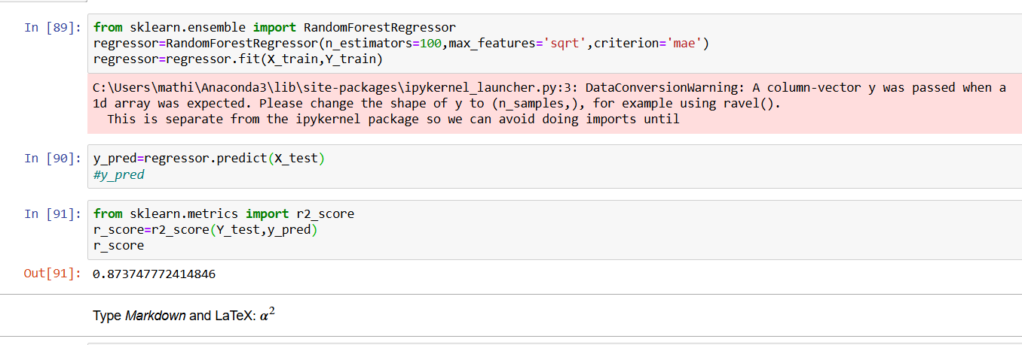

Final Model:
The Final model for the provided data set is derived by the algorithm – Random Forest with R2 value as 0.8737

Deployment Phase:

